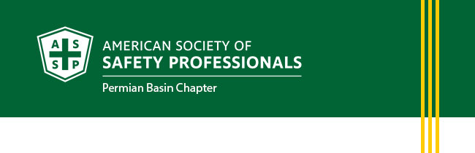
November Newsletter
- President's Letter
- Membership Updates
- Upcoming Events
- Career Opportunities

Thank you to our corporate sponsors:



PRESIDENT'S LETTER
Greetings Everyone!
As November arrives, it gives us an opportunity to pause and reflect on what matters most: the people we work beside, the families waiting for us at home, and the communities we serve.
For safety professionals, caring for people extends well beyond rules, procedures, and PPE. It means looking out for one another at work, on the road, at home, and during seasons when someone may be carrying more than we realize.
This month, the ASSP Permian Basin Chapter encourages everyone to practice gratitude, recognize service, stay focused on safety, and check in on the people around you.
Honoring Our Veterans
On Veterans Day, November 11, we pause to recognize the men and women who have served in the United States Armed Forces.
Across the Permian Basin, many veterans have transitioned their experience in military service into careers in safety, energy, construction, emergency response, transportation, and leadership. They continue to bring valuable lessons in teamwork, preparedness, accountability, and looking out for the person beside them.
To our veterans, including those within our ASSP community: thank you for your service, your sacrifice, and the leadership you continue to provide.
This Veterans Day, take a moment to personally thank a veteran in your workplace or community. A simple conversation and sincere expression of appreciation can mean more than we realize.
Thanksgiving Safety: Bring Everyone Home Safely
Thanksgiving is a time for family, food, travel, and traditions, but holiday activities can introduce hazards that may not be part of our normal routine.
In the Kitchen
Before the cooking starts:
- Keep children and pets away from hot cooking surfaces.
- Never leave stovetop cooking unattended.
- Keep towels, packaging, and other combustible materials away from heat.
- Keep an appropriate fire extinguisher accessible and know how to use it.
- If deep-frying a turkey, never place a frozen or partially frozen turkey into hot oil.
- Use turkey fryers outdoors, away from structures and combustible materials.
On the Road
For those traveling across West Texas or beyond:
- Buckle up on every trip.
- Put the phone away while driving.
- Plan for increased traffic and allow additional travel time.
- Never drive impaired.
- Avoid driving when fatigued. Stop somewhere safe and rest rather than trying to push through.
The same principles we emphasize at work apply at home: identify the hazards, understand the risk, put effective controls in place, and speak up when something doesn't look right.
The goal is simple: everyone arrives safely and everyone returns safely.
Mental Health Around the Holidays: Check on Your People
The holidays are often presented as a joyful time, but that isn't everyone's experience.
For some, the season can bring grief, loneliness, financial pressure, family stress, increased workloads, or memories of loved ones who are no longer here. Someone can appear completely fine at work while struggling privately. I personnally know how that feels when there are empty chairs at the table. My husband and I have both lost our younger brothers to accidents.
As safety professionals and leaders, we spend considerable time asking whether equipment, processes, and work conditions are safe. This season, let's remember to ask about the person, too.
Sometimes the most valuable thing we can do is slow down and genuinely ask:
- "How are you doing?"
- "How are things outside of work?"
- "Do you want to talk?"
- "Is there anything I can help you with?"
And most importantly, take time to listen to the answer.
Looking out for one another isn't separate from safety. It's part of safety.
If you or someone you know is experiencing a mental health crisis or needs immediate emotional support in the United States, call or text 988 to reach the Suicide & Crisis Lifeline. Everyone deserves to be here.
A Thanksgiving Message from Your Chapter President
As we head into the Thanksgiving season, I want to personally thank our ASSP Permian Basin Chapter members, volunteers, board members, sponsors, speakers, and community partners for your continued support.
I'm especially grateful to the safety professionals throughout the Permian Basin who show up every day with one goal in mind: making sure people go home safely.
Our profession is ultimately about people. Every conversation, field visit, safety meeting, intervention, and decision we make has the potential to make a difference in someone's life.
During this holiday season, I encourage each of us to take care of ourselves, check in on one another, recognize those who have served, and remember the reason behind everything we do.
Thank you for being part of our ASSP Permian Basin safety community.
Have a safe, healthy, and happy Thanksgiving!
Respectfully,
Heather Ferrell, CSP
President, Permian Basin Chapter
American Society of Safety Professionals
MEMBERSHIP UPDATES
Long Service Recognition of Chapter Members
- James Coleman, CSP: 26 years
- Milton Carey, CSP: 17 years
- Les Wooten, CSHM: 15 years

UPCOMING EVENTS
November Chapter Meeting
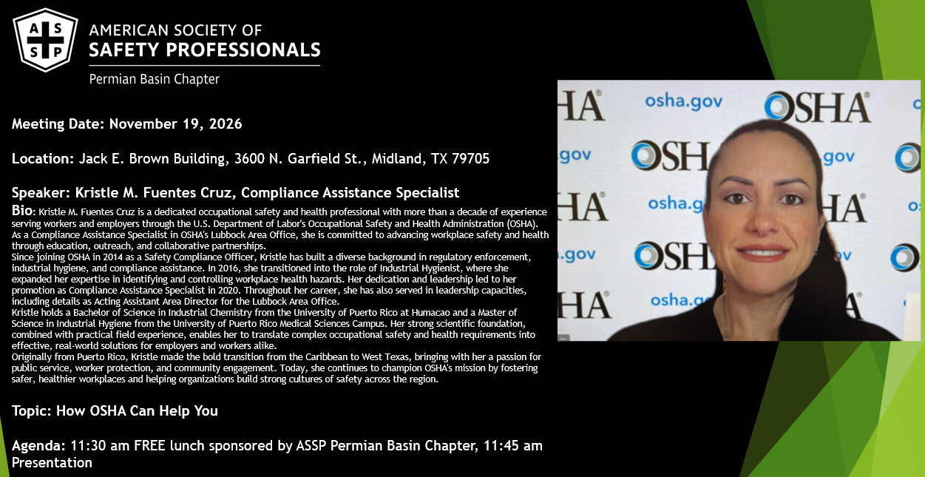
December Chapter Holiday Party
Friday, December 11 from 6:30 PM – 9:00 PM
Location: The Bar, 606 W. Missouri Ave., Midland, TX 79701
Make sure to RSVP on our website by December 7th!

Festival of Trees Volunteers and Toy Donations
The ASSP Permian Basin Chapter is sponsoring a tree for the 2026 Festival of Trees, and we need your help! We are looking for volunteers to help decorate our tree, toy donations and, members who want to help us give back to the Permian Basin community. Decorating will be on November 13th from 8:00 am - 7:00 pm (come and go).
Want to get involved? Contact Heather Ferrell president@permianbasin.assp.com or Megan Brown megan_brown@oxy.com and let us know how you'd like to help.
Safety Leadership Has No Job Title
Some of our strongest safety advocates don't have "safety" in their job title. The Safety Ally Award celebrates individuals who actively support safe work, look out for their coworkers, and positively influence the safety culture around them. The nomination's deadline is December 18th. Nominate someone who proves every day that everyone has a role in safety. Find more information on our LinkedIn page.

Recognize Excellence: Nominate a Safety Professional of the Year
The ASSP Permian Basin Chapter’s Safety Professional of the Year (SPY) Award recognizes an outstanding safety professional whose leadership, dedication, and contributions have made a meaningful impact on workplace safety and the HSE profession. Help us celebrate those who go above and beyond to protect others and strengthen the safety culture across the Permian Basin. The nomination deadline is December 18th and you can find more information on our LinkedIn page. Nominate a deserving safety professional today!

CAREER OPPORTUNITIES
We are always looking to network and find out if there are job openings. The jobs must be in an Environment, Health and Safety function. For example: Fleet Safety Manager, Director of Environmental, Health and Safety, Risk Manager, etc.
We will post the jobs to our website at president@permianbasin.assp.org. This is done currently at no charge, but the chapter is always accepting donations to help establish our scholarship fund. Your contribution is appreciated.

Please e-mail the job information to president@permianbasin.assp.org.
Visit the ASSP Permian Basin Chapter Jobs Website Page



If you do not wish to receive these emails, please click here
to unsubscribe from ASSP Permian Basin Chapter messages.
American Society of Safety Professionals | 520 N. Northwest Highway, Park Ridge, IL 60068

