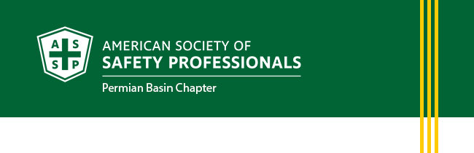
May Newsletter
- President's Letter
- Membership Updates
- Upcoming Events
- Career Opportunities
PRESIDENT'S LETTER
Warm Greetings,
May is recognized as Mental Health Awareness Month, and it serves as an important reminder that safety goes far beyond what we can see. In our industry, where we focus daily on physical hazards, procedures, and compliance, we must also prioritize something just as critical: the mental well-being of our workforce.
Mental health is not separate from safety, it is safety.
In high-demand environments like those across the Permian Basin, long hours, operational pressures, and time away from family can take a toll. While we emphasize wearing the right PPE and following Life Saving Rules, we must also ensure that we are creating a culture where individuals feel supported, heard, and valued.
Take a moment to reflect:
- When was the last time you checked in on a coworker beyond a simple “How are you?”
- Do you know what mental health resources are available within your organization?
- Are we fostering an environment where it’s okay to speak up, not just about hazards, but about how we’re feeling?
As safety professionals and leaders, we are in a unique position to influence this culture. Something as simple as a conversation, a moment of empathy, or pointing someone to the right resource can make a meaningful difference.
This Month’s Challenge
I encourage each of you to:
- Start one genuine conversation about mental health with a colleague
- Share available Employee Assistance Program (EAP) or local resources
- Consider incorporating mental health topics into your next safety meeting
- Lead by example, show that it’s okay to prioritize mental well-being
Mental health awareness is not just a one-month focus, it is an ongoing commitment to caring for our people.
Each one of us plays a role in building a stronger, safer, and more supportive industry. Let’s continue to look out for one another, both on and off the job.
You matter. Your team matters. Let’s make mental health part of our safety culture.
Respectfully,
Heather Ferrell, CSP
President, Permian Basin Chapter
American Society of Safety Professionals
MEMBERSHIP UPDATES
New Members
- Antoine Fantroy
- Derek Grinnell
- Robin Brooks
- Julio Soria
Long Service Recognition of Chapter Members
- Jeffrey Fenske, CSP, SMP, 16 years
- David Franco, Jr., CSP, 30 years
- Michael Anderson, CSP, 25 years
- Randy McClay, P.E., CSP, 31 years
- James D. Teigen, 37 years
UPCOMING EVENTS
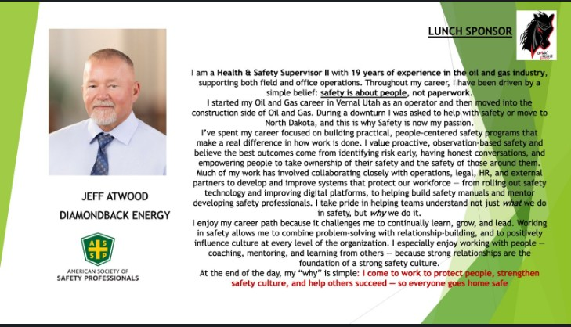May Chapter Meeting
Thursday, May 21 from 11:30 AM – 1:00 PM
Location: Jack E. Brown Building, 3600 N. Garfield St., Midland, TX
Speaker: Jeff Atwood, Diamondback Engery
Topic: What is your "WHY?"

CAREER OPPORTUNITIES
We are always looking to network and find out if there are job openings. The jobs must be in an Environment, Health and Safety function. For example: Fleet Safety Manager, Director of Environmental, Health and Safety, Risk Manager, etc.
We will post the jobs to our website at southtexas.asse.org. This is done currently at no charge, but the chapter is always accepting donations to help establish our scholarship fund. Your contribution is appreciated.

Please e-mail the job information to president@permianbasin.assp.org.
Visit the ASSP Permian Basin Jobs Website Page



