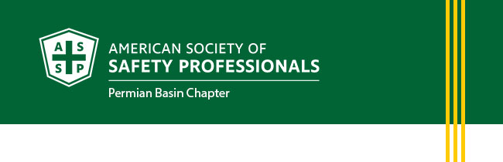
April Newsletter
- President's Letter
- Membership Updates
- Upcoming Events
- Career Opportunites
PRESIDENT'S LETTER
Greetings Safety Professionals!
It’s hard to believe we’re already well into the second quarter of the year. As the saying goes, the days are long, but the years are short. For me, April usually means refreshing the porch and backyard with flowers and native plants; projects that bring a welcome change of season. And what comes with planting? Digging.
April is National Safe Digging Month, making it the perfect time to pause and think before breaking ground. Whether you’re installing an in-ground sprinkler system or planting that beautiful desert willow, it’s critical to call 811 before you dig to have underground utilities located. Imagine accidentally striking the neighborhood fiber optic line and knocking out everyone’s internet. You probably wouldn’t be very popular at the next block party. More importantly, imagine striking a buried electrical line with a shovel and suffering a serious injury, or worse. It’s also worth asking: Are you verifying that your landscaper is making a One Call before starting work?
National Safe Digging Month serves as an important reminder that failing to locate underground utility lines leads to injuries, loss of life, and property damage every year, and this includes small residential projects. Safety doesn’t stop at the workplace; it’s something we must take home with us and practice every day.
By taking a few extra minutes to call 811 and confirm utility locations, we protect ourselves, our families, our neighbors, and our communities. Let’s use this month as an opportunity to reinforce safe habits, lead by example, and continue building a culture where safety comes first. On the job and at home.
Click the link below for more information from 811 on what’s required before you dig.
https://811beforeyoudig.com/
Respectfully,
Heather Ferrell, CSP
President, Permian Basin Chapter
American Society of Safety Professionals
MEMBERSHIP UPDATES
New Members
- Mary Meadows
- Rosalia Martinez
- Dawn-Marie Gillium
- Suzanne Rawlins
- Adam White, CSP, SMP
Long Service Recognition of Chapter Members
- Robert Heltzel, M.S., CSP - 30 years
- Krisha D. Marker, M.S., P.E., CIT, CSHO - 19 years
- Kyle C. O'Dell, CSP, CHMM, CHST, OHST - 17 years
- Jaon L. Hinkle, CSP - 15 years
UPCOMING EVENTS
April Chapter Meeting
Thursday, April 16 from 11:30 AM – 1:00 PM
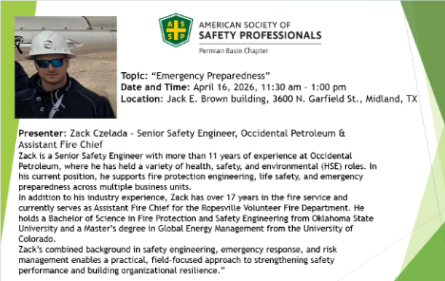
CAREER OPPORTUNITIES
We are always looking to network and find out if there are job openings. The jobs must be in an Environment, Health and Safety function. For example: Fleet Safety Manager, Director of Environmental, Health and Safety, Risk Manager, etc.
We will post the jobs to our website at permianbasin.assp.org. This is done currently at no charge, but the chapter is always accepting donations to help establish our scholarship fund. Your contribution is appreciated.

Please e-mail the job information to president@permianbasin.assp.org.
Visit the ASSP Permian Basin Jobs Website Page



