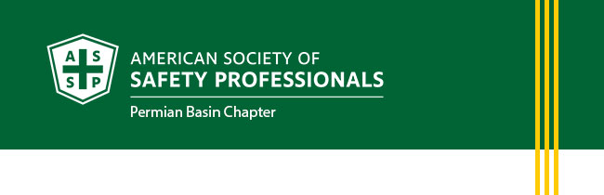
January Newsletter
- President's Letter
- Membership Updates
- Upcoming Events
- Career Opportunites
PRESIDENT'S LETTER
Dear Members,
I hope each of you has enjoyed a wonderful start to the New Year. As we step into 2026, I want to extend my sincere appreciation for your continued commitment to safety, both in your workplaces and within our community.
The beginning of a new year always brings a renewed sense of purpose, and for us as safety professionals, it’s an opportunity to refocus on what matters most: ensuring that everyone goes home safely, every day. Your dedication to advancing health, safety, and environmental excellence is what strengthens our profession and keeps our region moving forward.
As we look ahead, I’m excited for the opportunities this year will bring. Whether through professional development, collaboration, or community outreach, I am confident that together we will continue to make a meaningful impact. Thank you for your leadership, your engagement, and your unwavering passion for safety.
We will be sending out a survey later this month for you to fill out. Please provide us with your honest feed back as we want to make this the best chapter in the region!
Wishing you a safe, productive, and inspiring year ahead.
Warm regards,
Heather Ferrell, CSP
President, Permian Basin Chapter
American Society of Safety Professionals
MEMBERSHIP UPDATES
New Members
- Jason Clauser
Long Service Recognition of Chapter Members
- James Cash, 38 years
UPCOMING EVENTS
January Chapter Meeting
Thursday, January 16, 2026 from 11:30 AM – 1:00 PM
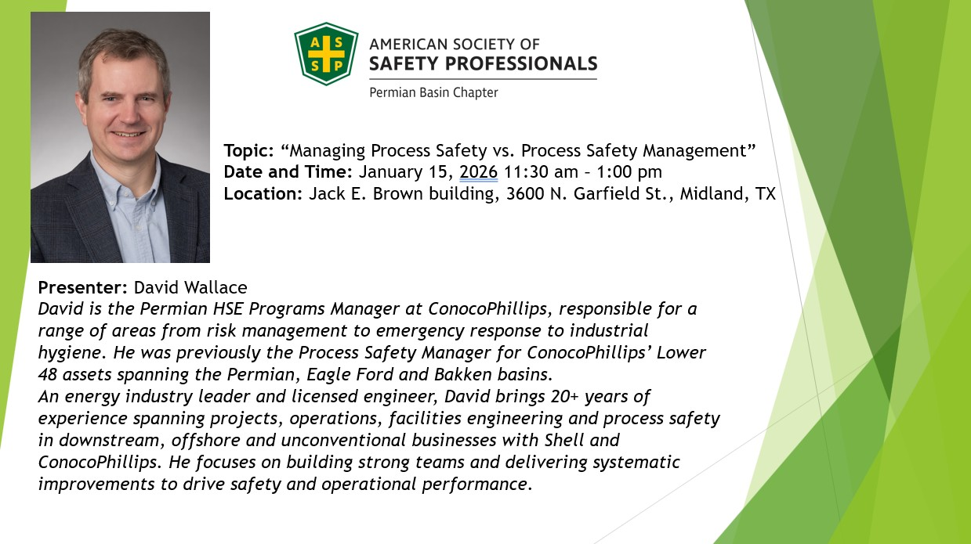
CAREER OPPORTUNITIES
We are always looking to network and find out if there are job openings. The jobs must be in an Environment, Health and Safety function. For example: Fleet Safety Manager, Director of Environmental, Health and Safety, Risk Manager, etc.
We will post the jobs to our website at southtexas.asse.org. This is done currently at no charge, but the chapter is always accepting donations to help establish our scholarship fund. Your contribution is appreciated.

Please e-mail the job information to updates@permianbasin.assp.org.
Visit the ASSP Permian Chapter Jobs Website Page



